The Siam Sinfonietta Concert

On the Occasion of the 83rd Birthday Anniversary of
Her Majesty Queen Sirikit of Thailand

on Wednesday, 12th August 2015 at 18.30-20.30 hrs.
at the Institute of Cultural Diplomacy (ICD) Genthiner Str. 20, 10785 Berlin
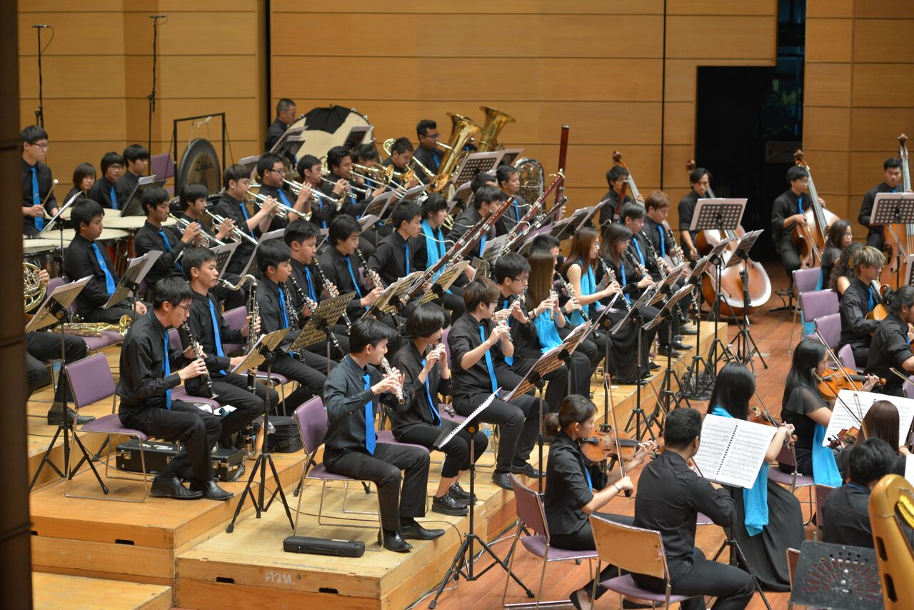

Siam Sinfonietta is the only Asian youth orchestra that was selected for Berlin’s prestige Young Euro Classic Festival in 2013. These young top-talent musicians are being directed by Somtow Sucharitkul, famous Thai composer, and Trisdee na Patalung, who is named “one of the world’s top ten conductors under thirty to watch” by the Italian press. They have performed and won many prizes at many well known venues of the world such as Musikverein in Vienna, Los Angeles International Music Festival as well as the Berlin Konzerthaus, Dresden Taschenberg Palais and the Prinzregententheather in Munich.

This year, after Bayreuth Festival of Young Artists in Bavaria, the Royal Thai Embassy has invited the Siam Sinfonietta to perform the concert on occasion of the 83rd Anniversary of Her Majesty Queen Sirikit’s Birthday on August 12th, 2015, at the Institute of Cultural Diplomacy (ICD) House in Berlin.
_______________________________________________________________________

Name: ………………………………………………………………………………

Institution: …………………………………………………………………………

Tel. /E-Mail: ………………………………………………………………………
Please reply to cultural@thaiembassy.de by 10 August 2015

